NAME: VENKATRAMAMOORTHY. G
- Create a counter using `useReducer` with actions: INCREMENT, DECREMENT, RESET.
CODE:
import { useReducer } from "react";
const initialState = {
count: 0,
};
function reducer(state, action) {
switch (action.type) {
case "INCREMENT":
return { count: state.count + 1 };

case "DECREMENT":
return { count: state.count - 1 };

case "RESET":
return { count: 0 };

default:
return state;
}
}

function App() {
const [state, dispatch] = useReducer(reducer, initialState);

return (
<div style={{ padding: "20px" }}>
<h1>Counter Using useReducer</h1>

<h2>Count: {state.count}</h2>
<button
onClick={() => dispatch({ type: "INCREMENT" })}
>
Increment
</button>

<button
onClick={() => dispatch({ type: "DECREMENT" })}
style={{ marginLeft: "10px" }}
>
Decrement
</button>

<button
onClick={() => dispatch({ type: "RESET" })}
style={{ marginLeft: "10px" }}
>
Reset
</button>
</div>
);
}

export default App;
OUTPUT:
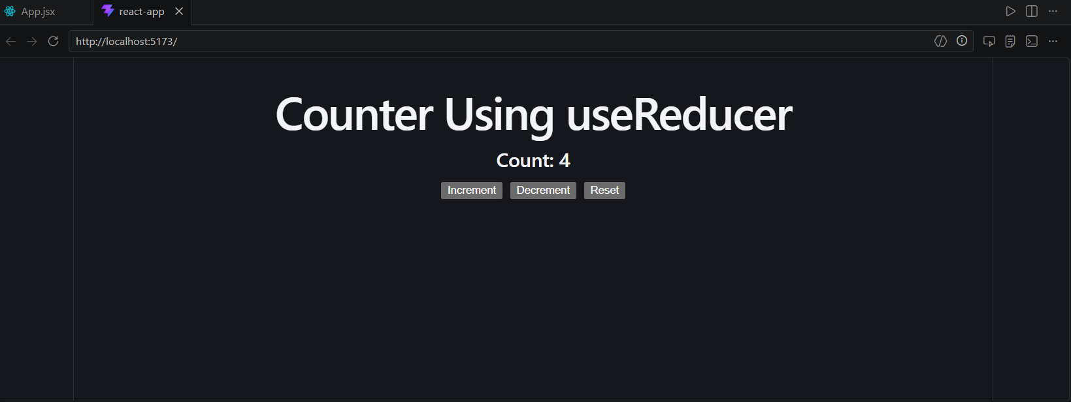

- Use `useRef` to focus the input when a 'Focus' button is clicked.

CODE:
import { useRef } from "react";

function App() {
const inputRef = useRef(null);
const handleFocus = () => {
inputRef.current.focus();
};

return (
<div style={{ padding: "20px" }}>
<h1>useRef Example</h1>

<input
ref={inputRef}
type="text"
placeholder="Enter text..."
style={{
padding: "10px",
marginRight: "10px",
}}
/>

<button onClick={handleFocus}>
Focus
</button>
</div>
);
}

export default App;

OUTPUT:
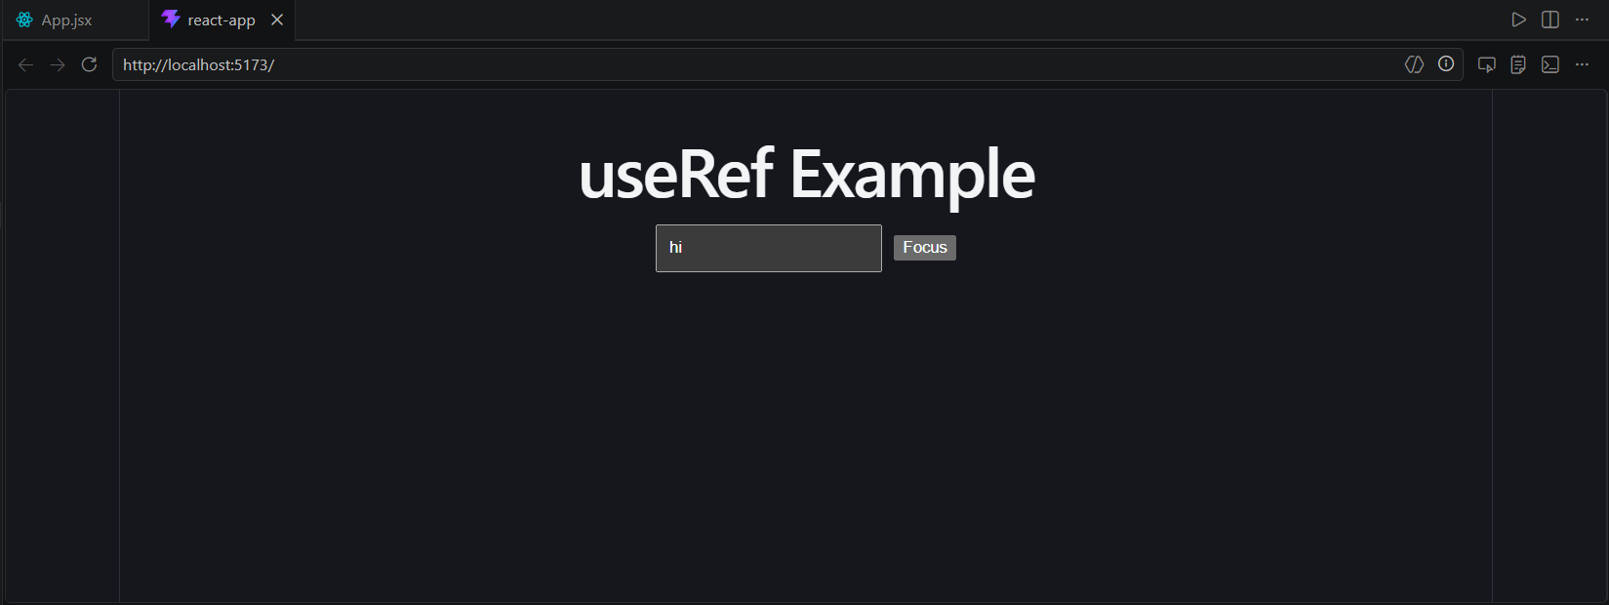
- Write a small utility to persist the counter in `localStorage` and rehydrate on load.
CODE:
import { useReducer, useEffect } from "react";
function loadCount() {
const saved = localStorage.getItem("count");

return saved ? Number(saved) : 0;
}
function saveCount(count) {
localStorage.setItem("count", count);
}

const initialState = {
count: loadCount(),
};

function reducer(state, action) {
switch (action.type) {
case "INCREMENT":
return { count: state.count + 1 };

case "DECREMENT":
return { count: state.count - 1 };

case "RESET":
return { count: 0 };

default:
return state;
}
}

function App() {
const [state, dispatch] = useReducer(reducer, initialState);
useEffect(() => {
saveCount(state.count);
}, [state.count]);

return (
<div style={{ padding: "20px" }}>
<h1>Counter with localStorage</h1>

<h2>Count: {state.count}</h2>

<button
onClick={() => dispatch({ type: "INCREMENT" })}
>
Increment
</button>

<button
onClick={() => dispatch({ type: "DECREMENT" })}
style={{ marginLeft: "10px" }}
>
Decrement
</button>

<button
onClick={() => dispatch({ type: "RESET" })}
style={{ marginLeft: "10px" }}
>
Reset
</button>
</div>
);
}

export default App;

OUTPUT:
